

Stallington Road,
196

Blythe Bridge,

Stoke
-
On
-
Trent,

ST11 9PA. United Kingdom

LED
O

-

Industrial Message Display Unit

Operating Instructions

Original Instructions

09/2025

Ref: LED
O
-
001

Legal Information

Disclaimer

This user manual provides information for the installation, commissioning, operation, and maintenance of the LED-O device. Every effort has been made to ensure that the information in this manual is accurate at the time of issue.

The manufacturer reserves the right to make technical changes without prior notice as part of continuous product improvement. The user is responsible for ensuring that the product is suitable for the intended application and is installed and used in accordance with this manual and all applicable local regulations.

Use of the device outside the specified operating conditions, unauthorised modification, or use with incompatible equipment may impair performance, invalidate compliance, and void the warranty. The manufacturer shall not be liable for damage resulting from misuse, incorrect installation, or operation contrary to the instructions in this manual.

This manual should be read in full before the device is installed or placed into service.

Warning notification

This manual contains important safety information. Safety notices are used to draw attention to hazards that may result in personal injury, damage to equipment, or damage to property if the instructions are not followed.

The safety symbols used in this manual identify the type and severity of the hazard. Always read and follow the accompanying instruction text before carrying out any work on the device.


Symbol

Meaning

Description and significance

DANGER

I
ndicates
the possibility of death or serious injury if appropriate safety measures are
not observed.

Avoid
the undertakings that are highlighted with this
symbol
.

WARNING

I
ndicates
the possibility of

death

or
serious injury if appropriate safety measures are
not
observed
.

Make sure to read and fully understand the relevant
proce
dures
before commencing
these

task
s
.

CAUTION

Indicates the possibility of
minor
personal injury
or impact to property

or the device

if appropriate measures are not observed
; approach
task with

caution.

DANGER

WARNING

CAUTION

Where more than one hazard exists, the highest applicable warning level is used.

Personnel

This product shall be installed, connected, and commissioned only by qualified personnel. Qualified personnel are persons who, through training, technical knowledge, and practical experience, are able to identify hazards and avoid risks associated with electrical equipment and industrial installations.

Product Compliance Statement

This product is intended to be designed, installed, and used in accordance with applicable regulatory requirements for the markets in which it is supplied. Compliance depends on correct installation, correct power supply provision, correct protective earth connection where specified, and use within the operating limits stated in this manual.

Unauthorised modification of the product, substitution of critical components, or use outside the specified ratings may invalidate product compliance and warranty.

Where EMC performance is dependent on installation practice, the installer is responsible for ensuring that wiring, cable routing, and associated equipment are arranged in accordance with good engineering practice and the instructions provided in this manual.
This manual has been prepared to support product evaluation and EMC test house review of the LED-O. References to standards, markings, classifications, and regulatory frameworks in this manual identify the design basis and intended assessment scope for the product. This manual is not itself a signed Declaration of Conformity or certification record.

For product support and compliance enquiries, contact the manufacturer using the details below.

Midlands Electronic Solutions

Address: 196 Stallington Road
Blythe Bridge
Stoke on Trent
ST11 9PA

Email: Contact details available on request from Midlands Electronic Solutions.

Telephone: +44 (0) 7730339627
Where the product is placed on markets that require an authorised representative or other designated economic operator, the relevant details will be provided in the applicable declaration, labelling, or accompanying documentation for that market.

Formal market-specific declaration documents, where required, contain the final economic operator and compliance details.

Figure 0.1 shows the general product labelling arrangement used on the device.

Contents
GB Declaration of Conformity notice ............................................................................................................6
EU Declaration of Conformity notice ............................................................................................................7
FCC Supplier’s Declaration of Conformity notice ......................................................................................... 8
Warranty Statement ..................................................................................................................................... 9
- Introduction and Preamble .....................................................................................................................10
  - Product Overview ..................................................................................................................................10
- Safety Information ................................................................................................................................. 11
  - Intended Use ........................................................................................................................................ 11
  - Product Parameters, Specifications and Limits .....................................................................11
  - Disposal ................................................................................................................................................ 13
  - Residual Risk ......................................................................................................................................... 13
    - Connecting the Main Power Supply ......................................................................................... 13
    - Potentially Explosive Atmospheres ........................................................................................... 13
    - Electromagnetic Compatibility ..................................................................................................14
    - Cleaning .................................................................................................................................... 14
    - Maintenance and Repair .......................................................................................................... 14
- Product Pre-use Checks ..........................................................................................................................15
  - Product Box Contents (Items Supplied) ............................................................................... 15
  - Product Inspection Checklist ................................................................................................ 15
  - Product Structure ................................................................................................................. 16
- Installation ..............................................................................................................................................17
  - Mounting .............................................................................................................................................. 17
  - Wiring ................................................................................................................................................... 17
    - Power Connections ................................................................................................................... 18
    - Communication Connections ................................................................................................... 18
- EMC Test Setup and Operating Mode ..................................................................................... 19
  - Bench Setup and Access .................................................................................................. 19
  - Operating Mode for EMC Evaluation ............................................................................... 19
  - PLC Coupling Information (by example) ................................................................................ 31
    - Recommended Lab Controls ................................................................................ 19
    - Network Reconfiguration .................................................................................... 30
- Technical Support ................................................................................................................................... 32
Appendix 1 – Dimensional Drawings .............................................................................................................. 33


GB Declaration of Conformity
This page is provided as an informational GB compliance notice for product review and EMC test house use. The formal signed GB Declaration of Conformity is maintained and issued separately as a controlled document.
This manual may reference applicable GB regulatory requirements and standards; however, the formal GB Declaration of Conformity is maintained separately as a signed controlled document. This page is included to identify the intended compliance route for review purposes only.


EU Declaration of Conformity
This page is provided as an informational EU compliance notice for product review and EMC test house use. The formal signed EU Declaration of Conformity is maintained and issued separately as a controlled document.
This manual may reference applicable EU regulatory requirements and harmonised standards; however, the formal EU Declaration of Conformity is maintained separately as a signed controlled document. This page is included to identify the intended compliance route for review purposes only.

FCC Supplier's Declaration of Conformity
This page is provided as an informational FCC compliance notice for product review and EMC test house use. Final market-specific FCC documentation, including responsible party details where required, is maintained separately for the applicable product configuration and market.
This device complies with Part 15 of the FCC Rules.
Operation is subject to the following two conditions:
- This device may not cause harmful interference, and
- This device must accept any interference received, including interference that may cause undesired operation.
This manual includes FCC-related compliance wording for the LED-O where relevant. Market-specific FCC status, responsible party information, equipment classification, and supporting test or declaration records are maintained in the controlled compliance documentation for the applicable LED-O product configuration and market of supply.

Warranty Statement

The LED-O is covered by a limited warranty against defects in materials and workmanship under normal use for a period of 12 months from the date of original purchase, unless otherwise agreed in writing.

During the warranty period, the manufacturer may, at its discretion, repair or replace a product found to be defective. Any repaired or replacement item remains covered only for the remainder of the original warranty period.

This warranty does not cover:

- Damage resulting from misuse, abuse, accidental damage, or unauthorised modification.
- Normal wear and tear or cosmetic damage.
- Damage caused by improper installation, operation outside the specified environmental or electrical limits, or use of non-approved accessories.

To make a warranty claim, retain proof of purchase and contact the manufacturer before returning the product. The product should be returned in suitable protective packaging where return is requested.

This warranty is limited to repair or replacement of the product. It does not cover indirect, consequential, or incidental losses arising from failure or misuse of the product.

This warranty applies in addition to any statutory rights that may apply in the country of purchase.

For warranty claims and product support, contact Midlands Electronic Solutions using the support details provided in this manual.

Midlands Electronic Solutions
Customer support
Email: Contact details available on request from Midlands Electronic Solutions.

Current support contact details are maintained by Midlands Electronic Solutions and should be confirmed before product return, service activity, or regulatory correspondence.

1 Introduction and Preamble

This manual provides the information required to unpack, inspect, install, commission, operate, and maintain the LED-O device safely and correctly. It is intended for installers, technicians, integrators, and other suitably trained personnel responsible for putting the product into service.

1.1 Product Overview

The LED-O is an industrial visual signalling and message display device designed to communicate machine, equipment, or process status information. It can display configurable text, colours, symbols, and graphics around its 360° display surface.

Features
- Configurable display content including text, colours, symbols, and bitmap graphics.
- Modbus TCP communication for integration with compatible PLC and control systems.
- High-brightness display designed for clear visibility in industrial environments.
- Energy-efficient LED technology with low routine maintenance requirements.
- Robust construction for use in suitable industrial indoor and protected outdoor applications, subject to the specified environmental limits.

Common Uses
- Industrial machinery, production equipment, and process systems requiring clear visual status indication.
- Industrial and commercial installations where configurable local visual messaging is required.

Compared with conventional stack lights that rely on fixed coloured modules, the LED-O provides a compact and configurable visual indication solution. Through Modbus TCP communication, the device can be integrated with compatible programmable logic controllers (PLCs) and configured to display colour-based status information, text messages, symbols, and bitmap images. When mounted in a suitable position on equipment or machinery, the LED-O provides clear visual feedback to operators and maintenance personnel.

2 Safety Information

2.1 Intended Use
The LED-O is intended for use as an industrial status indication and message display device on machinery, equipment, production systems, and process installations. Use outside this intended application shall be subject to a suitability assessment by the user or system integrator.

The device shall be installed and commissioned only in accordance with this manual, with particular attention to the stated operating limits, installation requirements, and safety instructions.

CAUTION

Intended Use
This product is intended for use as a status indication and signalling device for machinery, production equipment, process systems, and assemblies. Before installation, confirm that the product is suitable for the intended application and environmental conditions by reference to the specified product parameters, specifications, and operating limits in this manual.

2.2 Product Parameters, Specifications and Limits
Safe and reliable operation depends on correct transport, storage, installation, commissioning, operation, and maintenance. Failure to follow the instructions in this manual may result in damage to the product, damage to connected equipment, or personal injury.

Environmental Information

Applicable standards and environmental notes: | Applicable standards include BS EN IEC 60947-5-1:2025 for control circuit devices and signalling-related product requirements, as applicable to the reviewed product configuration.  RoHS conformity is addressed within the product compliance documentation and technical file for the applicable market configuration.  Waste electrical and electronic equipment obligations apply where the product is placed on markets that require separate collection, marking, or producer registration.
Enclosure material: | Resin-based polymer enclosure
Lens: | Clear acrylic tube
Climatic proofing: | Environmental testing is assessed against BS EN IEC 60068-2-38:2021 as applicable to the reviewed product configuration.
Mounting position: | Vertical post on base  Offset vertical post on base
Ingress protection: | Ingress protection for the reviewed assembly: IP65 to IEC 60529, subject to the supplied configuration and installation method.
Operating temperature limits (°C): | -20 °C to +60 °C
Operating humidity: | 10 % to 90 % RH
Warranty period: | 12 months

Electrical and installation information

Rated supply voltage [Us]: | 24 V DC ±10 %
Operating voltage limits - Max/Min: | 26.5 V DC / 21.5 V DC
Current consumption at 24 V DC: | 1.25 A maximum
Rated impulse withstand voltage V(esd): | 2 kV
Vibration resistance: | 10 g (f = 10…500 Hz) conforming to IEC 60068-2-6
Terminal conductor capacity: | Solid or flexible conductor = 0.13 - 1.5 mm²  Flexible with plastic-collared ferrule = 0.25 - 1.5 mm²
Supply cable: | The unit is supplied with 3 m of 2183Y 0.5 mm² 3-core flexible cable. Core identification: brown = +24 V DC, blue = 0 V DC, green = protective earth (PE).
Communication cable: | CAT5 Ethernet cable, 3 m, with RJ45 connectors fitted at both ends
Lifespan | >100,000 h

Integrated display module information

Input voltage: | 5 V DC
Average power consumption: | 250 W/m²
Maximum power consumption: | 580 W/m²
Horizontal viewing angle: | 160°
Vertical viewing angle: | 160°
Best viewing distance: | 5 m – 50 m
Grey level: | 14 bits
Brightness: | 600–1000 cd/m²
Brightness adjustment: | 100-step automatic/manual adjustment
Brightness Uniformity: | >99%
Pixel Pitch: | 4 mm
Panel dimensions: | 256 mm (W) × 128 mm (H)
Pixel Resolution: | 64 × 32 pixels
Pixel Configuration: | 1R1G1B
LED Specification: | SMD 3-in-1
Scan Rate: | Constant current 1/16 scan

Main board and interface information

 | Main board data
Surge and transient protection | TVS
 | Polarity protection in place
Rated supply voltage: | 24 V DC ±10 %
Current consumption at 24 V DC: | 1.25 A maximum
Output voltage screen limits - Max/Min: | 5.5 V DC / 4.5 V DC
Maximum current draw screen - | 2.0 A
Output voltage logic limits - Max/Min: | 3.3 V DC / 3.2 V DC
Logic voltage load limits – Min/Max | 3.2 V DC / 3.3 V DC
Maximum current draw Logic - | 0.3 A
Rated impulse withstand voltage V(esd) | 2 kV
Terminal capacity: | Solid or flexible conductor = 0.13 - 1.5 mm²  Flexible with plastic-collared ferrule = 0.25 - 1.5 mm²
Supply Cable: | Supplied power cable: 2183Y, 0.5 mm², 3-core flexible cable, nominal length 3 m. Core identification: brown = +24 V DC, blue = 0 V DC, green = protective earth (PE).
Ethernet | 10Base-T
Ethernet protection | CM choke and TVS protection
Communication cable: | Ethernet cable CAT5 with RJ45 connectors fitted at each end
Micro USB protection | USB common-mode choke and TVS protection

2.3 Disposal

At end of life, the product shall be collected and disposed of in accordance with applicable local regulations for electrical and electronic equipment. Do not dispose of the product with unsorted general waste.
Where applicable, the user is responsible for ensuring that the product is transferred to an approved waste handling or recycling facility. Materials should be recovered where practical in accordance with local environmental requirements.

For environmentally responsible disposal, use an authorised electronic waste recycling provider.

Always dispose of the product in accordance with the regulations applicable at the installation location.

2.4 Residual Risk

Although the product has been designed to reduce risk, some residual risks remain during installation, connection, operation, and maintenance. The following subsections describe those residual risks and the precautions required to reduce them.

2.4.1 Connecting the Main Power Supply

The device is designed for operation from a 24 V DC supply within the limits stated in this manual. Connection to an incorrect supply, incorrect polarity, or omission of the protective earth connection where specified may damage the product and may create an electrical hazard. Power connections shall be made only by qualified personnel.
Failure to observe the specified electrical ratings and installation requirements may result in equipment damage, electric shock risk, fire risk, or serious injury.

- Only qualified personnel shall carry out work on electrical connections. Appropriate isolation and safe working procedures shall be followed at all times.
- The supply circuit shall be protected by suitable overcurrent protection selected for the cable used and the installation requirements.
- Do not modify the product enclosure, internal wiring, or protective circuitry.

2.4.2 Potentially Explosive Atmospheres

This product is not designed or approved for use in potentially explosive atmospheres. It shall not be installed in areas requiring ATEX or equivalent hazardous-area certification.


Explosions can lead to
death or
serious personal injury.

This equipment is not ATEX rated and must not be used in any potentially explosive atmospheres

DANGER

2.4.3 Electromagnetic Compatibility

The LED-O is intended for installation in industrial environments. For EMC evaluation and for installations derived from the evaluated configuration, the device shall be mounted in its normal orientation and operated as installed equipment with the supplied 24 V DC power cable and the Ethernet communication connection in place. EMC performance depends on the complete installation arrangement, including cable routing, segregation from high-energy circuits, protective earth connection where specified, and the electromagnetic characteristics of the host equipment or panel.
To maintain EMC performance, route power and communication cables separately where practicable, avoid unnecessary cable length and loop area, and keep the LED-O away from known sources of severe electrical noise such as variable-speed drives, contactor switching loops, high-current conductors, and unfiltered switching equipment. Where the final installation differs materially from the representative test configuration, additional EMC verification may be required by the integrator or equipment manufacturer.

This product is designed for use in an industrial setting in accordance with according to EN61000
-
6
-
2
; operation of this product can cause radio interference in other settings.

CAUTION

2.4.3.1 EMC Test Configuration and Operating Conditions
For EMC testing, the LED-O should be evaluated in a representative worst-case operating condition that exercises the display electronics, internal power conversion, communication interface, and normal control functions. Unless a more onerous operating mode is defined in the test plan, the representative condition should include the unit energised at 24 V DC, active display output with dynamic content or high-load display operation, and the Ethernet interface connected and active.
The representative test configuration should include the supplied power cable of nominal length 3 m connected as specified in this manual, together with the Ethernet communication cable connected to a representative host, support equipment, or test network arrangement. Any auxiliary equipment required to establish communication or maintain the normal operating state of the LED-O during testing shall be included in the test setup and arranged in a manner representative of intended use.
During EMC evaluation, cables should be dressed and routed in a repeatable manner representative of the intended installation. Unused interfaces shall remain in their normal unused state. If alternative cable types, longer cable lengths, different grounding arrangements, or non-standard accessories are to be used in service, these may change the EMC behaviour of the installation and should be considered separately when defining the final EMC test plan.
- Define the intended EMC environment and the standard route to be applied for the tested LED-O configuration.
- Record the operating mode, display content, communication state, and any support equipment used during test.
- Record cable types, cable lengths, routing arrangement, and grounding/earthing conditions used during test.
- Define the acceptance criteria for functional performance during and after immunity testing.

2.4.4 Cleaning
Before cleaning, isolate the device from the power supply. Clean the external surfaces only using a dry or slightly damp non-abrasive cloth. Do not use solvents, aggressive cleaning agents, or excessive moisture.

Where electrostatic discharge precautions are required, use suitable ESD-safe materials and handling methods to reduce the risk of electrostatic damage during cleaning and maintenance.

2.4.5 Maintenance and Repair

The product contains no user-serviceable parts. If the product becomes faulty, remove it from service and contact the manufacturer for technical support or repair advice.

3 Product Pre-use Checks
Before installation or first use, unpack the product carefully and verify that all supplied items are present and free from visible damage.
3.1 Product Box Contents (Items Supplied)

3.1.1 Verify the supplied items

Confirm that all listed items have been supplied with the product:

- Main LED-O device, power cable, communication cable, and accompanying product documentation.
- Any additional mounting accessories specified for the ordered configuration.

3.2 Product Inspection Checklist
Before putting the device into service, carry out the following checks:

3.2.1 Inspect the device

- Ensure that the device housing is free from cracks, dents, or signs of impact.
- Make sure the screen/display is scratch-free and unbroken.

3.2.2 Check the remaining accessories

- Check that the cables are not frayed at the ends and the connectors are free from damage.
- Look for any signs of moisture ingress into the packaging.

3.2.3 Confirm product labels

- Check that the serial number, model identification, and any fitted product labels are present and legible. Regulatory markings shall be confirmed against the market-specific release status of the product.
- Ensure the packaging seal is still intact before opening.

3.2.4 Missing or damaged items
If any item is missing, damaged, or appears unsuitable for use:
Do not install, energise, or operate the device.
Retain the packaging and contact the supplier or manufacturer for further instructions.

3.3 Product Structure

The LED-O comprises a pre-assembled main body and mounting arrangement. The following illustrations show the principal product structure and a representative mounting arrangement.

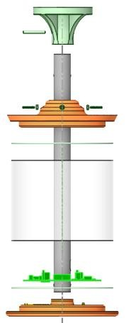
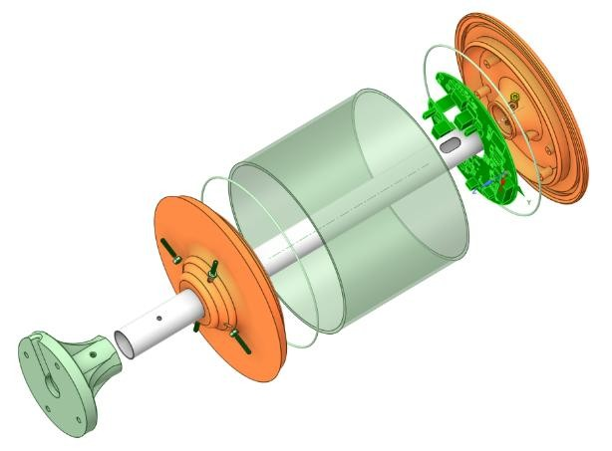
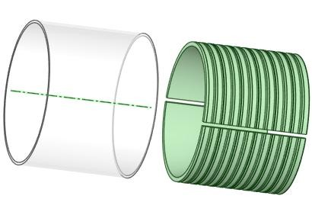

The power and Ethernet cables are routed through the dedicated support stand.

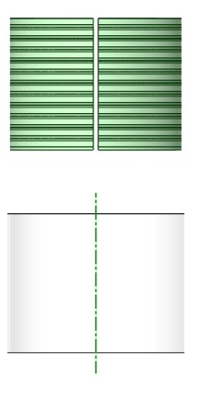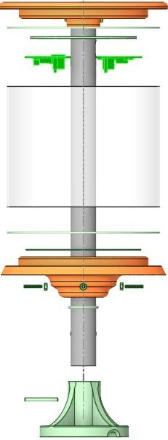
Display Lens

Display Screens

Foot Stand Locking Roll Pin

Top Cover

Top Cover Lens O Ring

Control Board

Display Lens

Bottom Cover Lens O Ring

Bottom Cover

Bottom Cover Locking bolts

Pipe Stand

Foot Stand

Top Cover Locking bolts

Bottom Cover Pole O Ring

Bottom Electrostatic Disc

Top Electrostatic Disc

4.2.1 Power Connections
The device is supplied pre-wired with a 3-core flexible power cable for connection to a 24 V DC supply. Connect the brown conductor to +24 V DC, the blue conductor to 0 V DC, and the green conductor to protective earth (PE) in accordance with the installation requirements and applicable local electrical regulations.
Typical 24 V DC wiring:
Brown → +24 V DC
Blue → 0 V DC
Green → Protective Earth (PE)
The wiring information above defines the required supply connection for installation and test purposes.

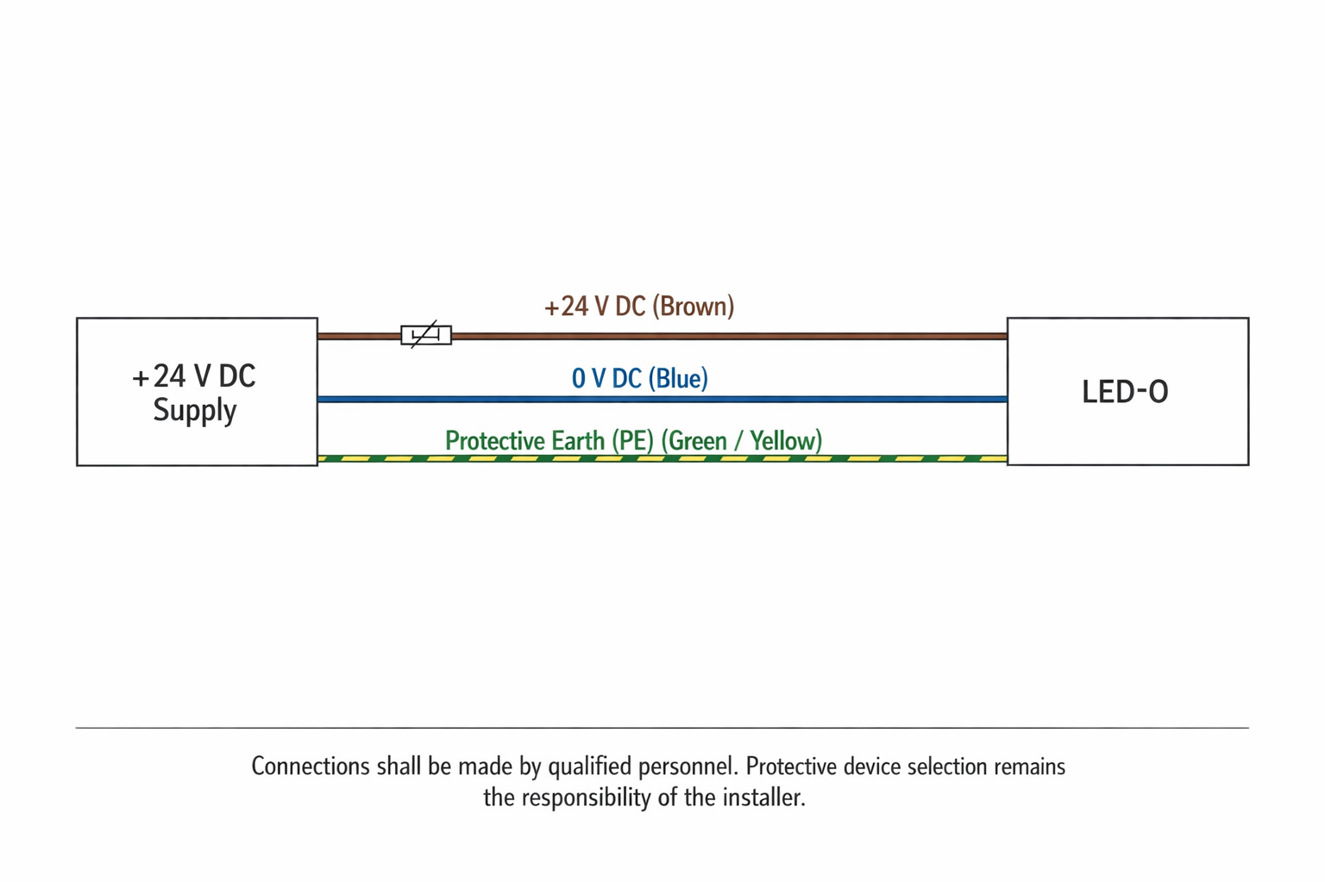

The unit is afforded class II protection which is defined as double insulated protection
. This
configuration

negates the need for a protective earth connection.

The following table summarises the supplied power cable characteristics.
Cable type | YY cable
Outer sheath | PVC, unscreened
Number of cores | 3
Conductor stranding | As specified by the cable manufacturer for the supplied cable type
Individual strand diameter | As specified by the cable manufacturer for the supplied cable type
Conductor cross-sectional area | 0.5 mm²
Overall outer diameter | As specified by the cable manufacturer for the supplied cable type
Approximate AWG equivalent | Approx. 20 AWG equivalent
Minimum bend radius | Fixed installation: refer to cable manufacturer specification  Occasional flexing: refer to cable manufacturer specification
Oil resistance | Refer to cable manufacturer specification
Armoured | No
Approximate cable mass | Refer to cable manufacturer specification
Minimum operating temperature | Refer to cable manufacturer specification for fixed and flexing conditions
Maximum operating temperature | Refer to cable manufacturer specification for fixed and flexing conditions

Where the installation arrangement may subject the cable to movement, flexing, or mechanical stress, the installer shall ensure that the selected routing and support method remain suitable for the environmental and mechanical conditions of use.

The LED-O includes internal protective circuitry intended to improve resilience against electrical disturbance. These protective components do not remove the requirement to connect the supply and protective earth conductors correctly where specified for the installation.
WARNING

The supply circuit should be protected by suitable overcurrent protection selected to suit the installation, the cable used, and applicable local electrical regulations. Selection of the protective device remains the responsibility of the installer.
The cable entry is arranged to provide retention at the point of entry. Care shall still be taken during installation to prevent excessive pulling, crushing, or repeated flexing of the cable.

4.2.2 Communication Connections
The device is supplied with an Ethernet communication cable terminated with RJ45 connectors. The internal connection is pre-assembled. During installation, ensure that the communication cable is routed and supported to prevent damage, undue strain, or accidental disconnection.

5 EMC Test Setup and Operating Mode

5.1 Bench Setup and Access
For EMC evaluation, power the LED-O from a 24 V DC supply in accordance with the installation instructions in this manual. Connect the supplied 3 m power cable and the supplied Ethernet cable. The device should be mounted or supported in a representative orientation and operated with all normal external connections fitted.
The LED-O includes an integrated web interface for initial access and configuration. Connect the supplied Ethernet cable between the device and a compatible PC or test network before attempting access.
When the device is powered without an active Ethernet connection, the display may indicate that no network connection has been detected. This confirms that power is present but communications are not yet established.

For a factory-default device, the default IP address is 10.0.0.49. Access the web interface from a compatible web browser on a PC configured within the same subnet.

If the address prompt is not shown on the display, enter the default IP address manually in the browser and confirm that the PC network settings are compatible with the device subnet.

5.2 Operating Mode for EMC Evaluation
For EMC evaluation, operate the LED-O in a representative worst-case condition that exercises the display, internal power conversion, and Ethernet communication interface. Unless a more onerous test condition is defined in the test plan, the recommended operating state is 24 V DC applied, Ethernet connected and active, and dynamic display content running during the test.
The web interface may be used to confirm network access and to place the unit into the required operating condition for test. The lab does not need to use every software function; only the controls necessary to establish the chosen display state and communication activity are required.

5.2.1 Recommended Lab Controls
5.2.1.1 Access and Display Control
After browser access has been established, use the web interface to place the LED-O into a stable representative test mode. Suitable examples include active text display, active graphics, rotation enabled, or another display state agreed as the worst-case operating mode for EMC assessment.
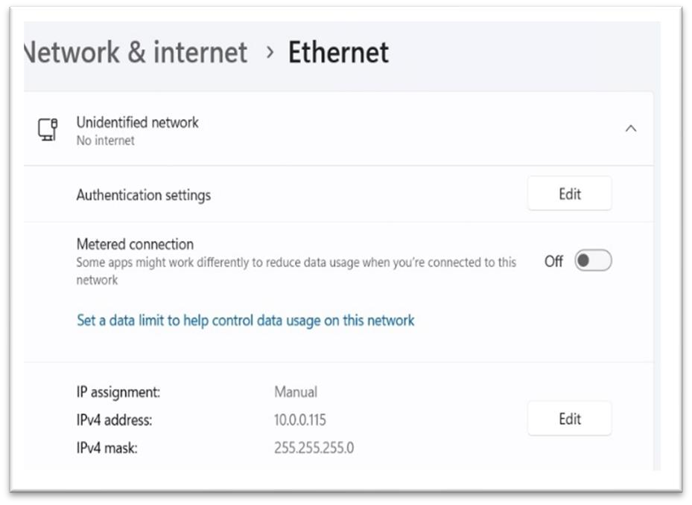

Figure 5.2.0

–

Network Settings

–

Working
Range

The register groups listed above define the principal display control parameters, including shape data, bitmap selection, borders, text position, units, scaling, alarm thresholds, rotation, screen fill, and message content. Integrators should map these registers in accordance with the host controller addressing method and test the configuration before routine operation.
Status Register

[String, Shape, Bitmap, Direction, Border, Fill, Clear, Rotate]

0 0 0 0 0 0 0 0
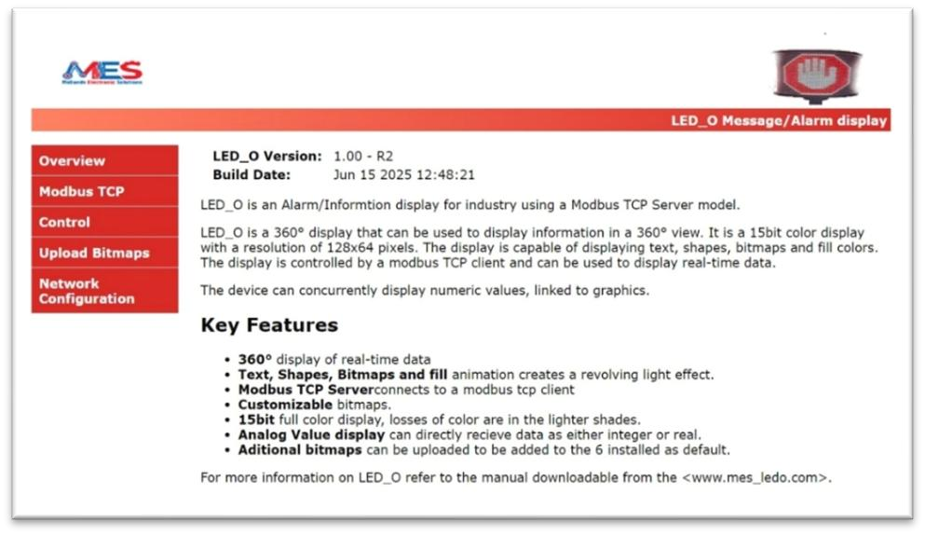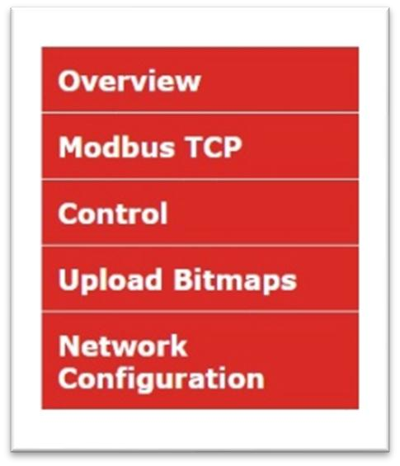
5.2.2.2
Parameters Settings

From the
“
Home
”

P
age

select the
“
Control
”

Page
.

This
page
will allow the user to interface with
the display in a
meaningful way
, not only for
programming the functions but

also for
testing

the functionality

of the programmed
functions
.

An example of the control page
is given below
.

From here various tasks can be programmed and tested on the unit
itself with instant real time

results.

Th
is

instantaneous

results based
approach to
the
user
set up and testing
enables the user to build
familiarity
with the
product
quickly
.

To

help the user further

a number of basic functions

are made

available for testing.

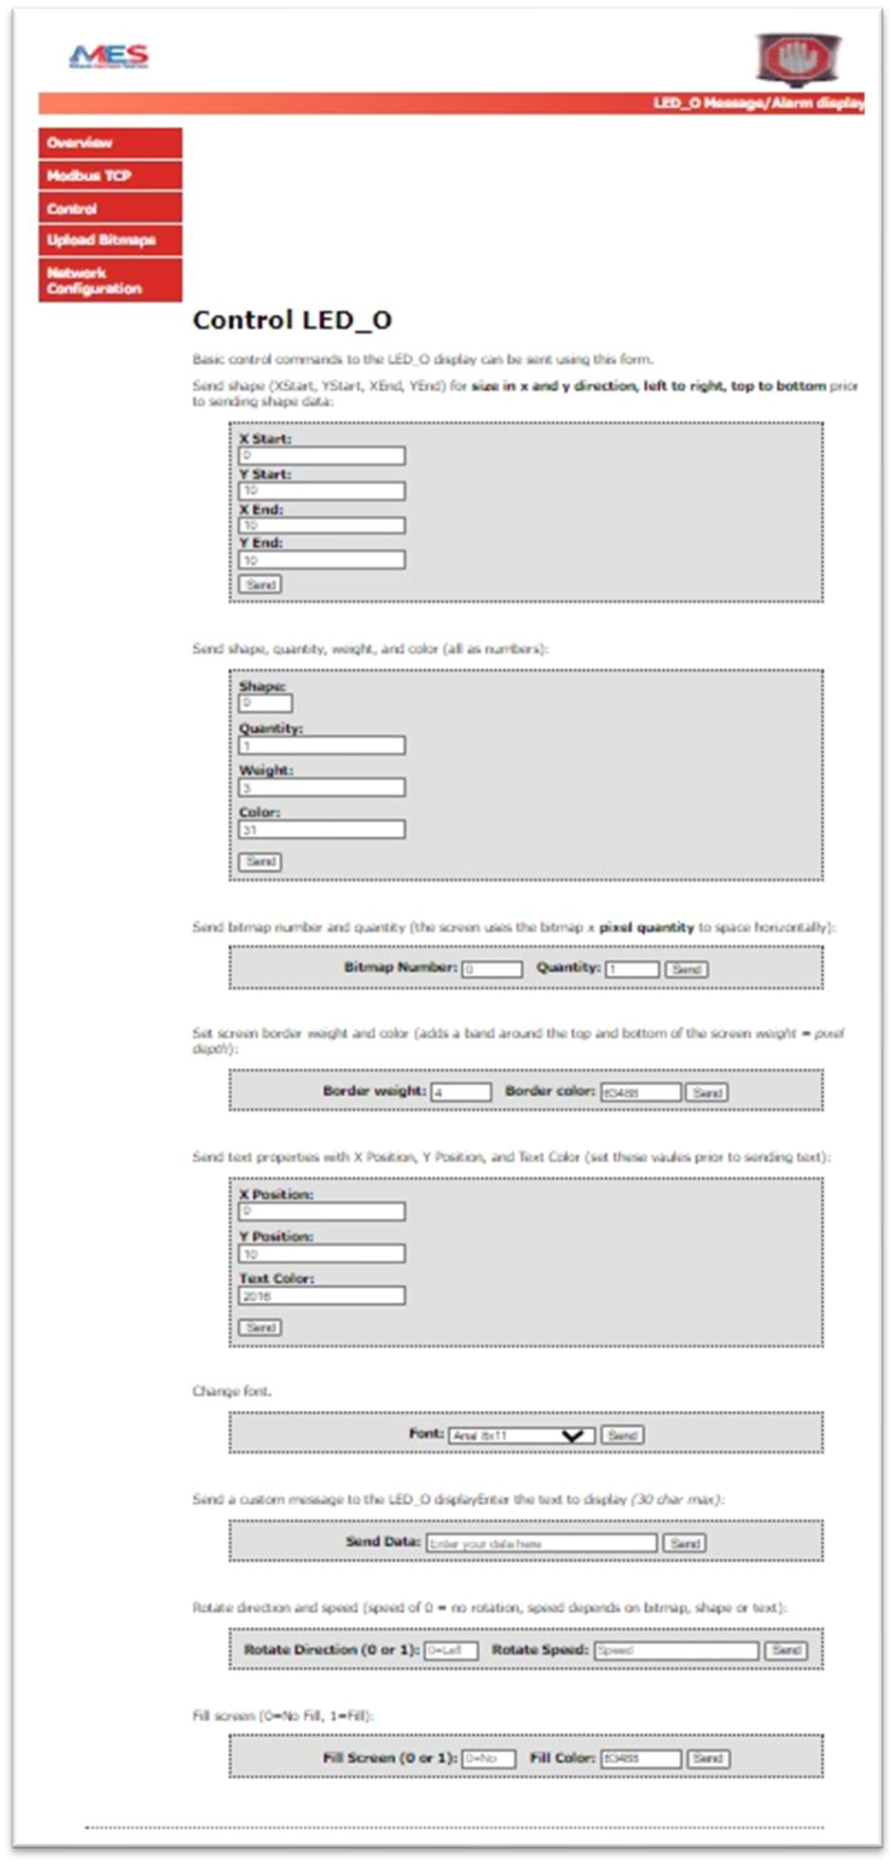







LED
-
0

Image/Text
Size

Par
ameter

LED
-
0

Basic Shapes

LED
-
0

Bit Map

Images

LED
-

0
Boarder

Setting

LED
-

0
Text
Size
& Colour
Setting

LED
-
0
Text
Font
Setting

LED
-
0
Text
Content

LED
-

0
Rotation

Setting

LED
-
0
Single
Colour

Setting

The following example shows how the control settings relate to pixel position when creating a basic rectangular shape.

Basic Shapes

Three basic shapes are available: rectangle, circle, and triangle. Select the required shape, quantity, line weight, and colour, then send the configuration to display the result on the LED-O.

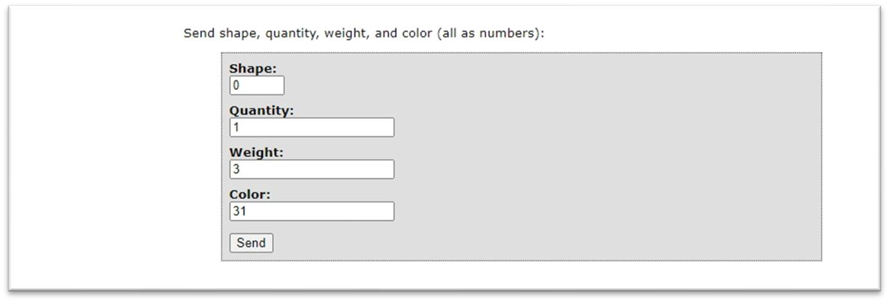

Note: Font colour uses a 16-bit format, with red = 63488 to 2048, green = 2016 to 32, and blue = 31 to 1.

Bitmap Images

The display unit contains ten pre-programmed bitmap images. Decimal values from 0 to 9 are used to select the required image for display.

Further information on the available pre-programmed images is provided in the section covering bitmap image upload and configuration.

Each bitmap is selected by its image reference number in the control page. Select the required bitmap reference and the quantity to be displayed, then send the configuration to update the LED-O display.

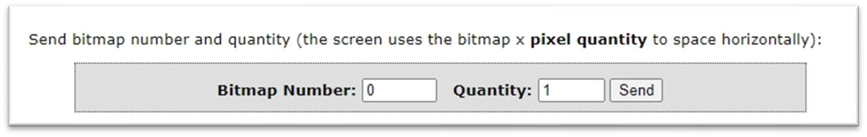
Bitmap images are limited to 32 x 32 pixels. Up to four bitmap images can be displayed across the screen. Higher quantities or larger image usage may reduce clarity, particularly when rotation is enabled.

Borders

Where a bitmap image is used at its maximum size, a border may not be visible because the available display area is already occupied by the image content.
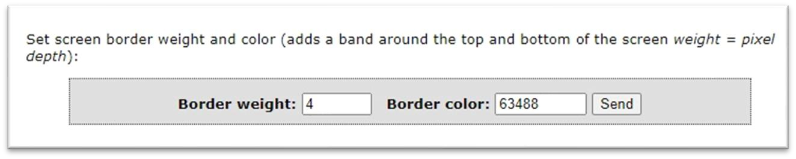

Text Size and Colour Settings

Text position and colour are configured within the text property settings. After selecting the required values, send the configuration to display the result on the LED-O. These parameters can be adjusted during operation independently of other display settings.

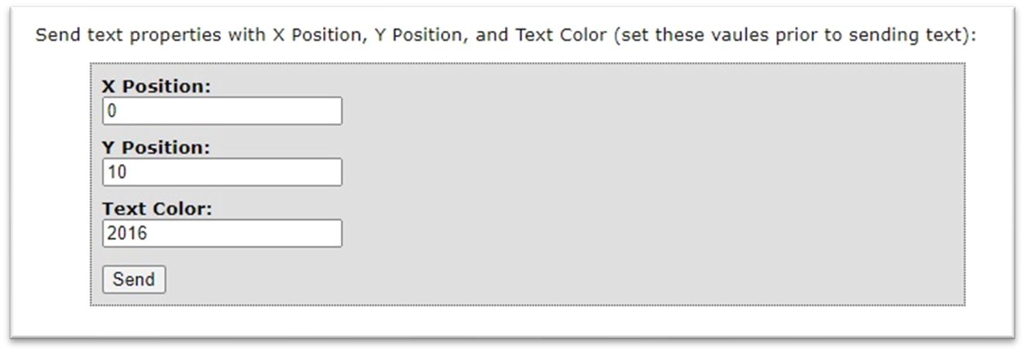

Text Font Settings

The required font can be selected from the following four options:

- Arial 8 x 11
- Rockwell 8 x 9
- Arial Italic 11 x 11
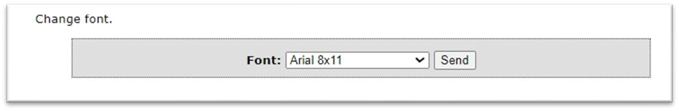
After selecting the required font, send the configuration to display the result on the LED-O. These parameters can be changed during operation independently of other settings.

Text Content

Project-specific text messages can be entered up to a maximum length of 30 characters.

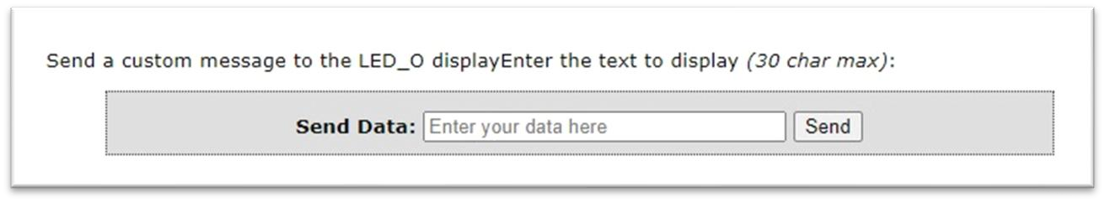
As with the other parameters, send the configuration after the text has been entered. Text settings can be adjusted during operation independently of other parameters.

Rotation Settings

Text and images can be scrolled around the display automatically. The available rotation settings include direction and speed.
- Direction: left or right.
- Speed: 0 = stationary (no rotation), 1 = fastest rotation speed, and 100 = slowest rotation speed.

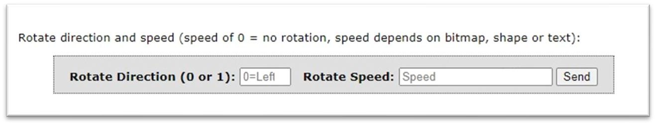
After selecting the required rotation settings, send the configuration to display the result on the LED-O. These parameters can be changed during operation independently of other settings.

Single-Colour Display Settings

In addition to complex shapes, images, and text, the LED-O can also be used as a simple single-colour status display. For example, the full display may be filled with a single colour to indicate a machine condition such as normal running, warning, or fault. Select the required colour and send the configuration to update the display.
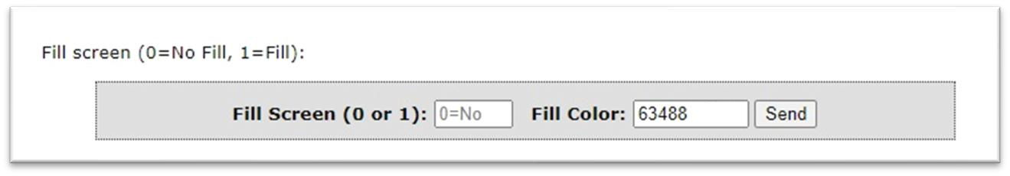
These parameters can be changed during operation independently of other display settings.

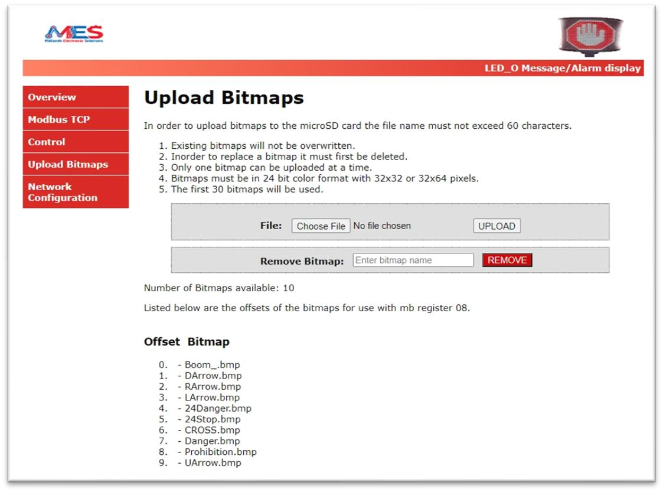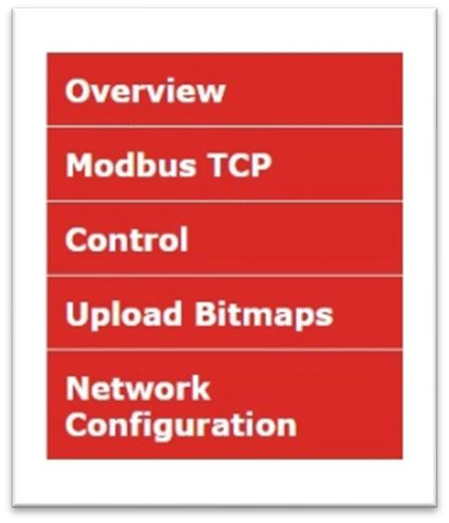
5.2.2.3

Uploading Bit Map Images

–

More
Details

From the “Home Page” select the Tab Upload Bitmaps. This will bring up the following page
:

As previously stated,
10

x
built
-
in bit map

images

are
provided with
each

LED
-
O
;
A decimal value of 0 to 9 will
represent the image that will be represented on the screen, once enabled
:

(0)

Boom.bmp

(1)

DownArrow.bmp

(2)

RightArrow.bmp

(3)

LeftArrow.bmp

(4)

24
Danger.bmp

(5)

Stop.bmp
24

(6)

Cross.bmp

(7)

Danger.bmp

(8)

Prohibition.bmp

(9)

UpArrow.bmp

Additional bitmap images and application-specific image support may be available on request. Contact Midlands Electronic Solutions directly to discuss custom requirements.

5.2.2.4 Network Reconfiguration
The network reconfiguration settings allow the factory-default IP address of 10.0.0.49 to be changed to suit the end-user network requirements.
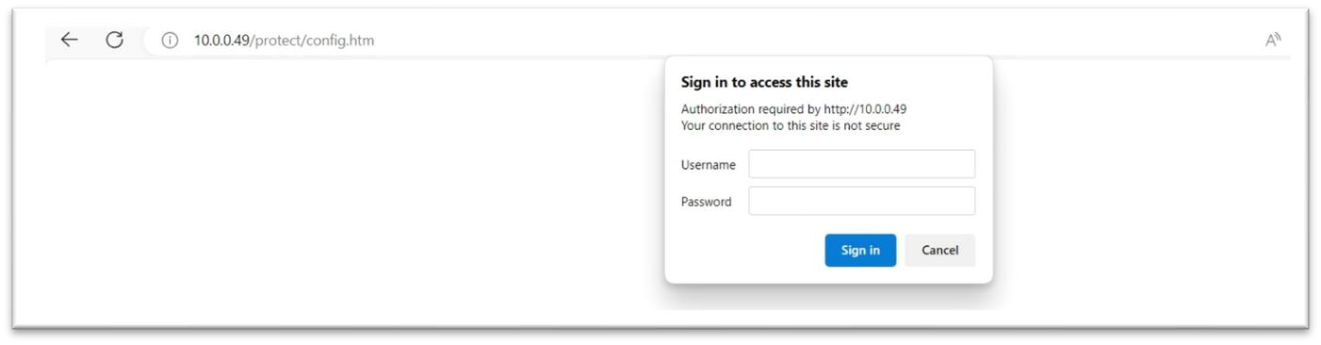
The default access credentials used during initial setup shall be controlled by the manufacturer or authorised user. Where default credentials are present during commissioning, they should be changed before the product is placed into routine service on a networked installation.

6 PLC Coupling Information (by example)
The previous section demonstrates the basic configuration functions available for the LED-O. This section builds on that information and shows, by example, how the LED-O can be linked to a third-party programmable logic controller (PLC).

The following list summarises the principal display functions represented in the example PLC program.
- Shape Border
- String
- Floating-point Value
- Text Colour
- Scaling
- Rotation
- Shape
- Font
- Fill Colour
In the example program, individual functions are enabled using bit values within a 16-bit word.
Parameter values in the example program are stored as 16-bit word values.

- Bitmap .............................................................................................. M10.0
- String ................................................................................................ M10.1
- Text Colour ....................................................................................... M10.3
- Scaling ............................................................................................... M10.4
- Rotation ............................................................................................ M10.5
- Shape ................................................................................................ M10.6
- Border ............................................................................................... M10.7
- Font .................................................................................................. M11.0
- Fill Colour .......................................................................................... M11.1
- Config ............................................................................................... M11.2

Floating-point value ........................................................................................ DB6DBD738
- X Position Shape / PMP Start ............................................................ DB6DBW672
- Y Position Shape / PMP Start ............................................................ DB6DBW674
- X Shape Size ...................................................................................... DB6DBW676
- Y Shape Size ...................................................................................... DB6DBW678
- Shape ................................................................................................ DB6DBW680
- Shape Quantity ................................................................................. DB6DBW682
- Shape Weight ................................................................................... DB6DBW684
- Shape Colour .................................................................................... DB6DBW686
- BMP .................................................................................................. DB6DBW688
- BMP Quantity ................................................................................... DB6DBW690
- Border Weight .................................................................................. DB6DBW692
- Border Colour ................................................................................... DB6DBW694
- Text Pos X ......................................................................................... DB6DBW696
- Text Pos Y ......................................................................................... DB6DBW698
- Font Colour [B=31, G=2016, R=63488] .............................................. DB6DBW700
- Font Type .......................................................................................... DB6DBW702

•  •  •  •  •  •  •  •  •  •  •  •  31 | Example PLC data block assignments shown in this section illustrate how application parameters such as SI unit selection, decimal place, scaling limits, alarm thresholds, rotation direction, rotation speed, screen fill, and fill colour may be mapped in a controller program. These mappings are provided as an integration example only and should be reviewed and adapted to suit the final control system architecture.  Fill colour .......................................................................................... DB6DBW626

7 Technical Support
For technical support, product information, service enquiries, or controlled product documentation updates, contact Midlands Electronic Solutions using the current support details in force at the time of issue.

Appendix 1 – Dimensional Drawings
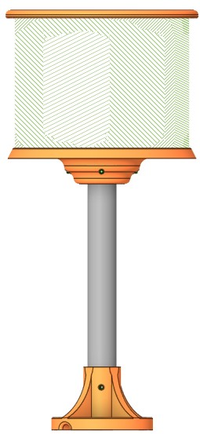

50
mm
.00

(
+
/
-

mm
)
0.5

12
.00
mm

(
+
/
-

0.5
)
mm

181
.00
mm

(
+
/
-

)
mm
0.5

190
mm
.00

(
+
/
-

mm
0.5
)

7
.
58
mm

(
+
/
-

mm
)
0.5

10
.00
mm

(
+
/
-

)
mm
0.5

124
.
5
0
mm

(
+
/
-

)
mm
0.5

180
.00
mm

(
+
/
-

)
mm
0.5

25
.00
mm

(
+
/
-

)
mm
0.5

100
.00
mm

(
+
/
-

0.5
mm
)

290
.
00
mm

(
+
/
-

0.5
mm
)

Conclusion
This manual provides the information required for the safe installation, commissioning, operation, and maintenance of the LED-O device. Correct product performance depends on installation in accordance with the instructions, operating limits, and applicable local electrical and safety requirements.
Before the product is placed into service, the installer or system integrator shall confirm the suitability of the installation, including power supply provision, protective earth connection, environmental conditions, and communication setup. Formal market-specific declarations and release records, where required, are maintained separately within the controlled compliance documentation.
For technical support, service information, or controlled product documentation updates, contact Midlands Electronic Solutions using the current support details in force at the time of issue.

